PROGRESS REPORT · AI & COMPUTER VISION
What Makes AI-Based Sparse-View 3D Gaussian Splatting Work?
Separating the roles of predicted camera poses, predicted 3D points and pose refinement
Team | Supervisor | Report date | Project status
Farida Gaber, Mona Yasser | Dr. Wedad Sallam | 9 November 2026 | Block 1 of 4 (ends 11 Nov) · deadline 25 Nov

1. Summary
We are studying why a modern AI-based method (InstantSplat) can build a 3D scene from only 3 to 9 photos. We will switch its parts on and off, one at a time, to see which part creates the quality. In the first block we built and checked the full experiment setup.
Key results so far
Setup works: the full pipeline runs on free Google Colab and is shared with the team (Drive, GitHub, live tracker).
Milestone M1 passed: our baseline matches the published numbers within 0.6 dB (PSNR 14.70 / 16.39 / 17.19 vs 14.10 / 15.83 / 17.16 at 3 / 6 / 9 photos).
Two hidden problems found and fixed in the original code, so that all later comparisons are fair.
Main open point: computing time. All 96 planned runs need about 22.5 GPU-hours on the free GPU.

2. The project in plain words

What is 3D Gaussian Splatting?
3D Gaussian Splatting (3DGS) turns photos of a scene into a 3D model that can be viewed from new angles. It needs the camera pose of every photo: where the camera stood and where it pointed. With 100+ photos the classic tool (COLMAP) computes these poses well. With only 3 to 9 photos it often fails.

How AI helps
New AI models (here MASt3R) predict the camera poses and a 3D point cloud directly from a few photos. InstantSplat combines three parts: (1) AI-predicted poses, (2) AI-predicted 3D points, and (3) pose refinement, which corrects the poses during training. Nobody has tested which of these three parts matters most when only 3 to 9 photos are available.

Research question
How much of the quality comes from the AI's predicted poses, its predicted 3D points, and pose refinement, and how does this change from 3 to 9 photos? In particular: do the dense-view findings of VGGT-X still hold with only 3 to 9 photos?

Method: change one part at a time
Config | Camera poses | 3D points | Refinement | What it tells us
C1 | Reference (from the dataset) | AI (MASt3R) | Off | Best case for poses
C2 | AI (MASt3R) | AI (MASt3R) | Off | Pure AI prediction
C3 | AI (MASt3R) | AI (MASt3R) | On | Full InstantSplat (baseline)
C4 | AI (MASt3R) | Random | On | Value of the AI points

Comparisons: C1 vs C2 = effect of poses · C3 vs C4 = effect of 3D points · C2 vs C3 = effect of refinement. Data: Mip-NeRF 360, 8 real 360° scenes, 3 / 6 / 9 training photos. Plan: 4 configs × 3 photo counts × 8 scenes = 96 runs. A fifth configuration with a newer AI model (VGGT) is optional.

3. What we have done
Date | Work | Outcome
3–6 Nov | Related work: Google Scholar search and the research tools Elicit, Consensus and Perplexity; about 30 papers read; research gap defined (Farida) | Our first idea was already published, so we sharpened it. Gap found: no study separates the three parts at 3–9 photos
3–6 Nov | Proposal, presentation and day-by-day plan for two people | Detailed proposal (PDF), slides and tracker; 4-block relay plan to 25 Nov
9 Nov | Set up InstantSplat on Google Colab (free T4 GPU) | Works after 4 compatibility fixes; setup cached on Drive so it restarts in minutes
9 Nov | Dataset and test rule | 8 scenes ready; same rule as the Free360 paper: every 8th photo = test photo
9 Nov | Baseline: full InstantSplat (C3) on 2 scenes × 3 / 6 / 9 photos = 6 runs | Matches the published numbers (Section 4) → milestone M1 passed
9 Nov | Quality control of the original code | Two problems found and fixed (Section 5)
9 Nov | Team sharing | Shared Drive folder, private GitHub repo, live Google Sheet tracker, project log

4. First results
Before changing anything, we checked that our setup gives the same numbers as a published paper (Free360, which also tested InstantSplat). PSNR measures how close the rendered test images are to the real photos (higher is better).
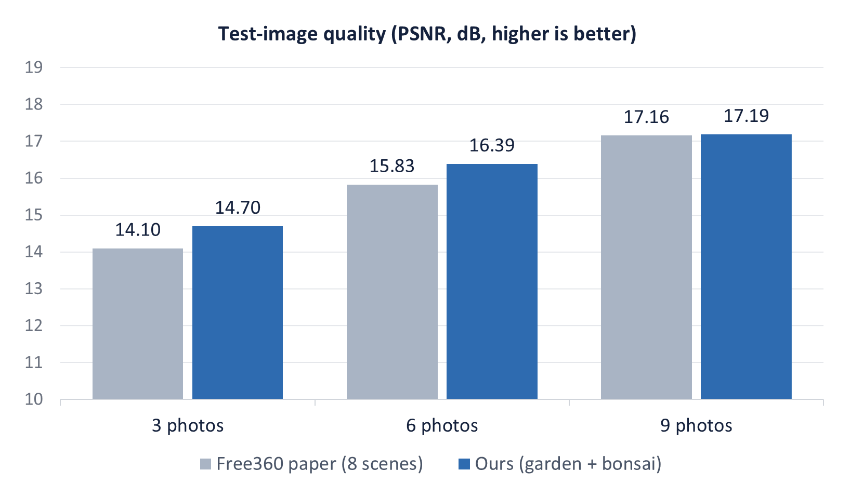
Figure 1. Test-image quality: our baseline vs the published Free360 numbers.
Photos | Our PSNR ↑ | Free360 PSNR ↑ | Difference | Our SSIM ↑ / LPIPS ↓ | Free360 SSIM ↑ / LPIPS ↓
3 | 14.70 | 14.10 | +0.60 | 0.315 / 0.568 | 0.296 / 0.529
6 | 16.39 | 15.83 | +0.56 | 0.367 / 0.450 | 0.351 / 0.480
9 | 17.19 | 17.16 | +0.03 | 0.389 / 0.413 | 0.402 / 0.443

Per scene (time and GPU memory per run on the free T4 GPU):
Scene | Photos | PSNR ↑ | SSIM ↑ | LPIPS ↓ | Time (min) | GPU memory (GB)
garden | 3 | 14.65 | 0.273 | 0.555 | 8.9 | 3.2
garden | 6 | 17.58 | 0.345 | 0.396 | 12.4 | 3.7
garden | 9 | 18.04 | 0.344 | 0.377 | 16.8 | 4.8
bonsai | 3 | 14.75 | 0.358 | 0.581 | 9.9 | 3.3
bonsai | 6 | 15.20 | 0.390 | 0.503 | 15.4 | 3.7
bonsai | 9 | 16.34 | 0.434 | 0.449 | 21.1 | 4.9

What this means
Our setup is correct: every photo count is within 0.6 dB of the paper (our target was 1.5 dB), so we can trust the next experiments.
Quality improves with more photos, as expected. The outdoor scene (garden) gains most from 3 to 6 photos.
Caution: Free360 averages 8 scenes, we used 2, so small differences are normal.

5. Problems found and fixed
Problem | Fix | Effect
Before measuring, InstantSplat guesses where each test camera is. In 360° scenes this first guess was 80–90° wrong. | Start each test camera from its reference position, aligned to the AI's cameras. The same rule is used for every configuration. | garden PSNR rose from 14.23 / 14.52 / 14.76 to 14.65 / 17.58 / 18.04; the benefit of more photos is now visible
InstantSplat's camera-error code mixes two camera formats and gave impossible values (up to 145°). | We wrote our own script (pose_error.py) and checked it with automatic tests. | Valid camera-error numbers from the next runs (re-run planned)

Why this matters: both problems would have made the comparison between configurations unfair or misleading.

6. Computing time
- 14 minutes per run on average on the free T4 GPU (9 to 21 minutes; more photos take longer).
- 65% of each run is spent fine-tuning the test cameras before measuring. The method requires this step.
- 22.5 GPU-hours for all 96 runs, about 11 hours for each of us.
- Memory is not a problem: at most 4.9 GB of the 15 GB GPU.
Options (decision before 16 Nov): split the runs over our two free Colab accounts as planned; buy Colab compute units for a guaranteed GPU; use the RTX 5090 workstation as back-up; or, as a last resort, reduce to 4 scenes (48 runs). All final runs will use one GPU type.

7. Status and next steps

Still open in Block 1 (by 11 Nov)
Task | Owner | Status
Re-run the baseline with the updated notebook (valid camera errors, dataset copy on Drive) | Farida | In progress
Mona runs the notebook once on her own account | Mona | Not started
Overleaf + Zotero set-up; get the DPR-Splat paper | Farida | In progress
15-minute hand-off call (Block 1 → Block 2) | Both | In progress

Plan to the deadline
Dates | Block (lead) | Goal
9–11 Nov | Block 1 (Farida) | Setup + baseline — main result done
12–15 Nov | Block 2 (Mona) | Add the switches C1, C2, C4; test each on 1 scene; 24 pilot runs on 2 scenes
16–18 Nov | Block 3 (both) | All 96 runs; results tables and figures (milestone M2)
19–23 Nov | Block 4 (Mona) | Analysis and paper draft; Farida checks every number
24–25 Nov | Final (both) | Send to Dr. Wedad Sallam; apply feedback; deliver

8. Questions for the supervisor
- Is an analysis / ablation study acceptable, or is a new method required?
- What is the target output: course report, thesis chapter or workshop paper?
- Compute for the 96 runs: free Colab, paid Colab units or the RTX 5090 workstation?

9. Where to find everything
- GitHub (private): github.com/Farida-gaber44/sparse-view-3dgs-ablation — notebook, scripts, project log (LOG.md), slides.
- Live tracker (Google Sheet): linked in the GitHub README; both of us update the status there.
- Shared Google Drive folder 3dgs-project: setup files, dataset copy and all run results.
- Colab notebook: notebooks/01_block1_setup_baseline.ipynb — press Run all; finished runs are skipped.

Glossary
Term | Meaning
Camera pose | Where a camera stood and where it pointed when the photo was taken
Sparse-view | Building a 3D scene from only a few photos (here 3, 6 or 9)
Reference poses | Very accurate poses computed by COLMAP from all 100–300 photos of a scene (part of the dataset)
Pose refinement | Correcting the camera poses during 3D training
Ablation study | Turning parts of a method on or off, one at a time, to measure what each part contributes
PSNR / SSIM / LPIPS | Image-quality scores comparing rendered and real test photos (higher, higher, lower is better)
GPU / T4 | Graphics card that runs the training; the T4 is the free GPU on Google Colab

